**Front-End UI/UX Mini Project**

* **Submitted By**: 
  + *2462324 Deon Biju*  [deon.biju@btech.christuniversity.in](mailto:%20deon.biju@btech.christuniversity.in)
  + *2462357 San Antony Saji*

[san.antony@btech.christuniversity.in](mailto:san.antony@btech.christuniversity.in)

* + *2462369 Tom John Jimmy*

[tom.john@btech.christuniversity.in](mailto:tom.john@btech.christuniversity.in)

* **Course**:  *UI/UX Design Fundamentals*
* **Instructor Name**: *Mrs. Nagaveena*
* **Institution**:  *Christ University*
* **Date of Submission**: *13/08/2025*

**PET ADOPTION CENTRE**

**2. Abstract**

This project involves designing and developing a responsive **Pet Adoption Center** website to showcase available pets for adoption, including their breed, age, and photos. The site is created using HTML and CSS with a focus on simplicity, clarity, and accessibility. The website provides a warm, friendly design to encourage potential adopters to explore available pets and take action. Dedicated sections include a colorful header, a pet listing grid, and a footer with contact and location details.

**3. Objectives**

• Design a visually appealing pet adoption interface that attracts and engages visitors  
• Develop a responsive grid layout to display multiple pet profiles  
• Implement structured HTML5 semantic elements for clear content organization  
• Apply consistent CSS styling for branding, colors, and button interactivity  
• Ensure ease of navigation and readability on all devices

**4. Scope of the Project**

• Focused entirely on front-end design (no backend or database integration)  
• Optimized for desktop, tablet, and mobile viewports  
• Built using only pure HTML and CSS without libraries or frameworks  
• Aimed at creating an informational and engaging display of adoptable pet

• Focused on front-end design only  
• No JavaScript or server-side functionality  
• Optimized for desktop, tablet, and mobile viewports  
• Developed using pure HTML and CSS without frameworks or libraries

**5. Tools & Technologies Used**

|  |  |
| --- | --- |
| Tool/Technology | Purpose |
| HTML5 | Markup and content structure |
| CSS3 | Styling and layout management |
| VS Code | Code editor |
| Chrome DevTools | Testing and debugging |

**6. HTML Structure Overview**

• Used semantic tags: <header>, <section>, <footer>  
• Structured into three main sections: Header (branding & tagline), Pet Listings, and Footer (contact details)  
• Pet listings implemented as individual <div> cards with headings, images, descriptions, and buttons

**7. CSS Styling Strategy**

• Used an external CSS file (Pet.css) for better maintainability  
• Applied Flexbox for arranging pet cards into a responsive grid layout  
• Techniques used:  
o Box shadows and rounded corners for a soft, friendly aesthetic  
o Theme colors (#ff9800 for warmth and positivity)  
o Hover effects on buttons for interactivity  
o Media-flexible image styling to ensure consistent sizing

**8. Key Features**

|  |  |
| --- | --- |
| Feature | Description |
| Responsive Design | Pet cards rearrange neatly for different screen sizes |
| Visual Branding | Warm orange color scheme to create a welcoming feel |
| Pet Profile Cards | Displays name, breed, age, image, and an “Adopt Me” button |
| Simple Navigation | All content presented in a single scrolling view |
| Contact Information | Footer contains address and phone number for inquiries |

**9. Challenges Faced & Solutions**

|  |  |
| --- | --- |
| Challenge | Solution |
| Maintaining card alignment on smaller devices | Used Flxexbox with flex-wrap to stack cards |
| Making images fit without distortion | Applied max-width: 100% and border radius |
| Consistent button styling across browsers | Used CSS resets and hover state styling |

**10. Outcome**

• Successfully created a clean, friendly, and functional pet adoption site using only HTML and CSS  
• Layout adapts smoothly to different devices without breaking design elements  
• Improved skills in creating responsive layouts and maintaining consistent branding **11. Future Enhancements**

• Add a search or filter feature to find pets by type or age  
• Include a functional adoption application form  
• Integrate a backend system to manage pet listings dynamically  
• Add animations for smoother visual transitions when hovering or loading cards

**12. Sample Code**

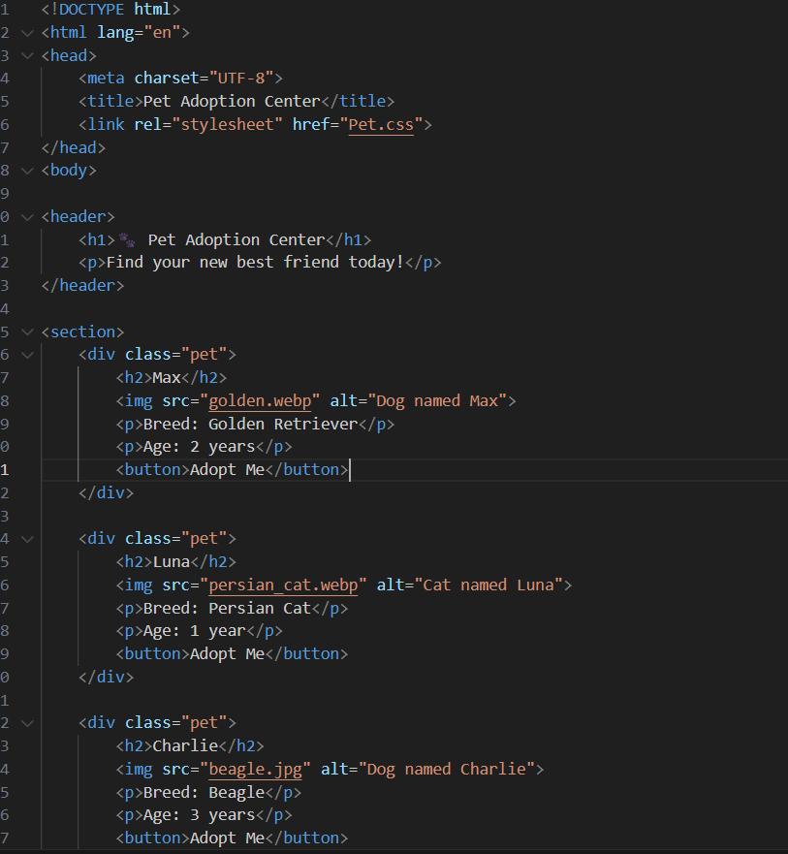

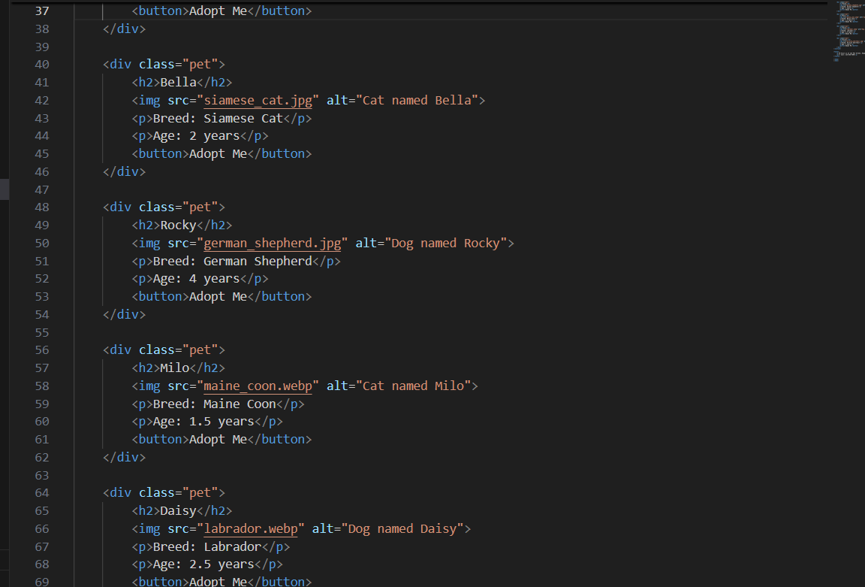

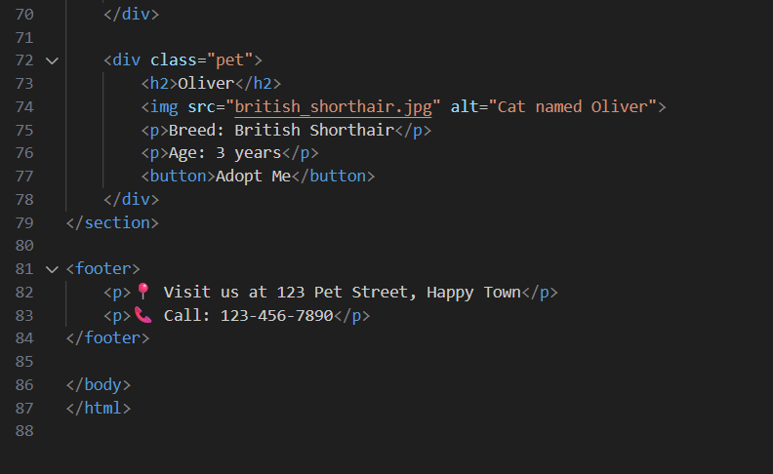

**13. Screenshots of Final Output**

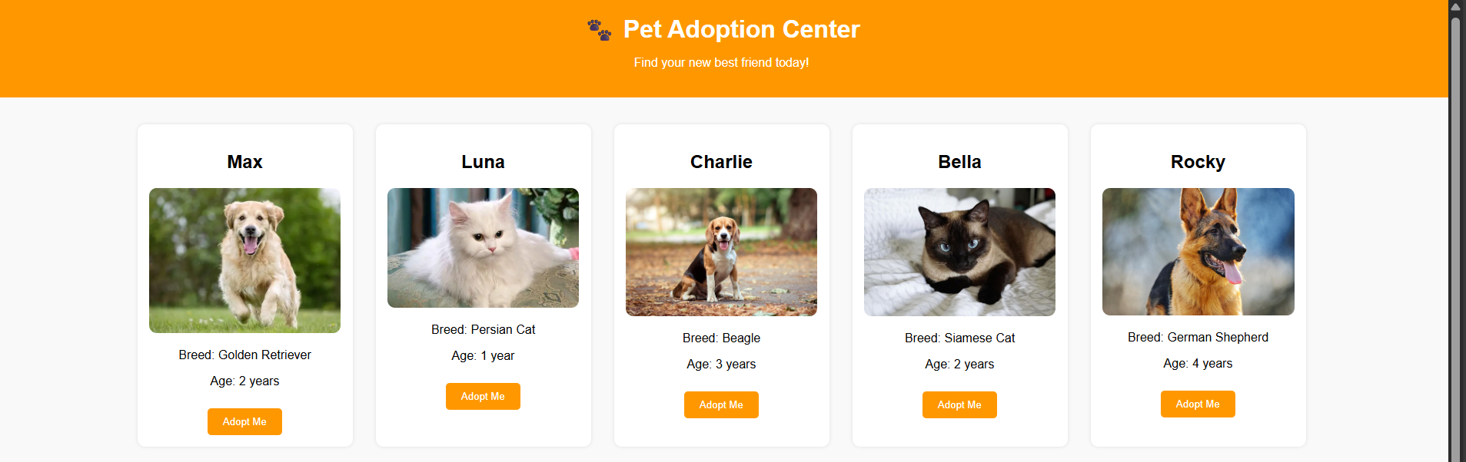

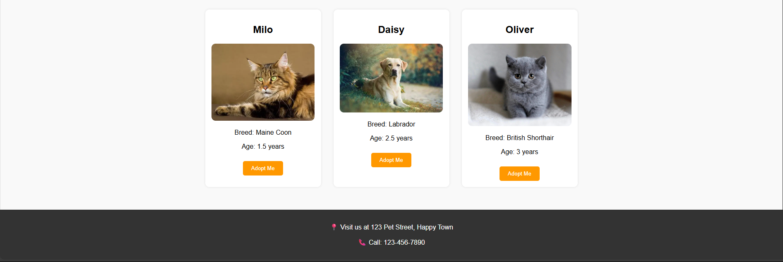

**11. Conclusion**

The Pet Adoption Center website effectively presents adoptable pets in an organized, visually appealing, and responsive layout using only HTML and CSS. The project improved our proficiency in Flexbox-based layouts, image handling, and aesthetic styling while reinforcing concepts of accessibility and user engagement. By simulating a real-world application, it provided practical experience in creating a clean interface that serves its purpose—encouraging visitors to connect with the adoption center. The project also deepened our appreciation for design elements that influence user behavior.

**12. References**

* L&T LMS : https://learn.lntedutech.com/Landing/MyCourse